We have uploaded the results and deep models to
BaiduYun (https://pan.baidu.com/s/1u0TZqmmHEzt6TX6Te75VRA)
and
OneDrive (https://1drv.ms/u/s!An-BNLJWOClliGSEa6QY9TVedqJH?e=8vSWld ).

Please download these zipped files and unzip them into the folders ‘results/levin/’. The folder tree is as follows:
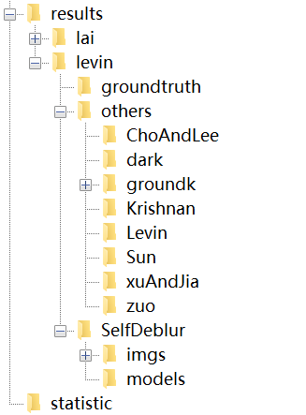
Then you can run ‘statistic/statistic_levin.m’ to compute the metrics reported in the paper.

